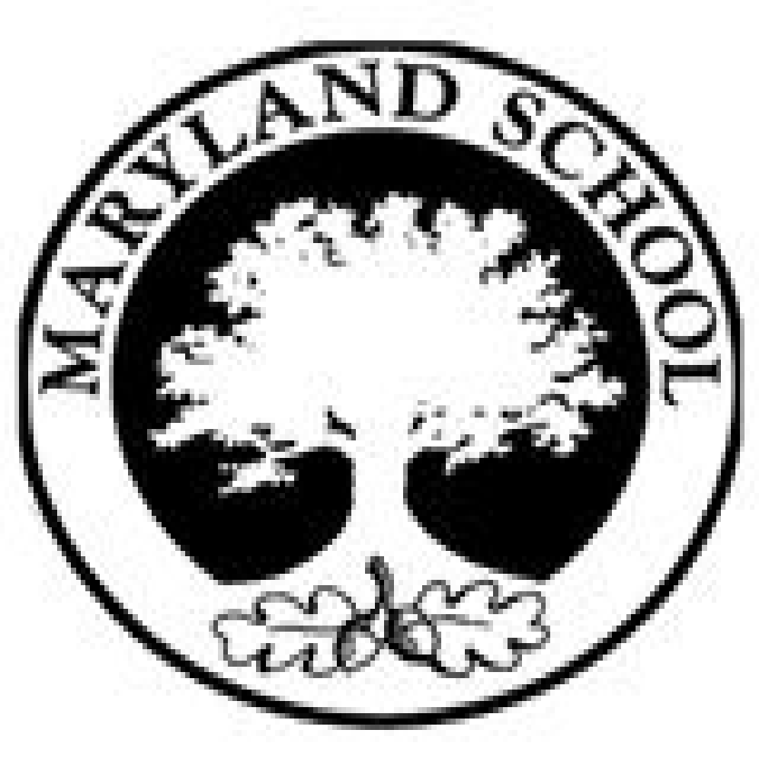

Maryland Primary School Privacy Notice

How we use pupil information
- Maryland Primary School is the data controller of the personal information you provide to us. This means the school determines the purposes for which, and the manner in which, any personal data relating to pupils and their families is to be processed. Each school has a Data Protection Officer (DPO). Louise Malina, based at NPW, acts as a representative for the school with regard to its data controller responsibilities. Her role is to oversee and monitor the school’s data protection procedures, and to ensure they are compliant with the GDPR. General Data Protection Regulation is a regulation in EU law on data protection and privacy for all individuals within the European Union. The Data Protection Officer can be contacted on DPO@npw.uk.com.
- In some cases, your data will be outsourced to a third party processor; however, this will only be done with your consent, or unless the law requires the school to share your data. Where the school outsources data to a third party processor, the same data protection standards that Maryland Primary School upholds are imposed on the processor.
The categories of pupil information that we collect, hold and share include:
- Personal information (such as name, unique pupil number and address)
- Characteristics (such as ethnicity, language, nationality, country of birth and free school meal eligibility)
- Attendance information (such as sessions attended, number of absences and absence reasons, punctuality)
- Assessment and achievement information
- Relevant medical information
- Special educational needs information
- Behaviour and learning information
- Catering and Free School Meal management
- Safeguarding
- Trips and activities

Why we collect and use this information
Maryland Primary School holds the legal right to collect and use personal data relating to pupils and their families, and we may also receive information regarding them from their previous school, local authority (LA) and/or the Department of Education (DfE). We collect and use personal data in order to meet legal requirements and legitimate interests set out in the GDPR and UK law, including those in relation to the following:
- Article 6 and Article 9 of the GDPR
- Education Act 1996
- Regulation 5 of The Education (Information About Individual Pupils) (England) Regulations 2013

In accordance with the above, the personal data of pupils and their families is collected and used for the following reasons:

- to support pupil learning
- to monitor and report on pupil progress
- to provide appropriate pastoral care
- to assess the quality of our services
- to comply with the law regarding data sharing
- to safeguard pupils

Storing pupil data
Personal data relating to pupils at Maryland Primary School and their families is stored in line with the school’s GDPR Data Protection Policy. In accordance with the GDPR, the school does not store personal data indefinitely; data is only stored for as long as is necessary to complete the task for which it was originally collected.

Will my information be shared?
The school is required to share pupils’ data with the DfE on a statutory basis. The National Pupil Database (NPD) is managed by the DfE and contains information about pupils in schools in England. Maryland Primary School is required by law to provide information about our pupils to the DfE as part of statutory data collections, such as the school census; some of this information is then stored in the NPD.

The DfE may share information about our pupils from the NDP with third parties who promote the education or wellbeing of children in England by:
- Conducting research or analysis.
- Producing statistics.
- Providing information, advice or guidance.
The DfE has robust processes in place to ensure the confidentiality of any data shared from the NDP is maintained. Maryland Primary School will not share your personal information with any third parties without your consent, unless the law allows us to do so. The school routinely shares pupils’ information with:
- Pupils’ destinations upon leaving the school
- The Local Authority
- The NHS
- The DfE

What are your rights?
Parents and pupils have the following rights in relation to the processing of their personal data.
You have the right to:
- Be informed about how Maryland Primary School uses your personal data.
- Request access to the personal data that Maryland Primary School holds.
- Request that your personal data is amended if it is inaccurate or incomplete.
- Request that your personal data is erased where there is no compelling reason for its continued processing.
- Request that the processing of your data is restricted.
- Object to your personal data being processed.
Where the processing of your data is based on your consent, you have the right to withdraw this consent at any time. If you have a concern about the way Maryland Primary School and/or the DfE is collecting or using your personal data, you can raise a concern with the Information Commissioner’s Office (ICO). The ICO can be contacted on 0303 123 1113, Monday-Friday 9am-5pm.
Where can you find out more information? If you would like to find out more information about how we and/or the DfE collect, use and store your personal data, please visit our website (www.maryland.newham.sch.uk) or download our GDPR Data Protection Policy.
_____________________________________________________________________________________________________

Maryland Primary School Privacy Notice

Declaration
I, as the Parent/Carer of _______________________________, declare that I have received the Privacy Notice and have read and understood the following;
Maryland Primary School has a legal and legitimate interest to collect and process my personal data in order to meet statutory requirements.
How my data is used.
Maryland Primary School may share my data with the DfE, and subsequently the local authority. Maryland Primary School will not share my data to any other third parties without my consent, unless the law requires the school to do so. Maryland Primary School will always ask for explicit consent where this is required, and I must provide this consent if I agree to the data being processed. My data is retained in line with the school’s GDPR Data Protection Policy.

Signature______________________________________________________________Date__________________
Name_________________________________________________________________

