MARYLAND PRIMARY SCHOOL HOME-SCHOOL AGREEMENT | OUR SCHOOL
AGREEMENT FOR PUPILS  To help me do well at school, I will do my best to:  Be the best that I can be.  Work hard and listen carefully to instructions.  Come to school every day and aim for 100% attendance and be on time.  Make sure I have the proper equipment for lessons, including PE kit.  Do all my homework and hand it in on time.  Tell someone if I am having problems and always tell the truth.  Follow the class and all school rules, wear the school colours and be tidy in appearance.  Respect others, behave well and be polite, kind and helpful to others.  Signed:………………………………..……………... | AGREEMENT FOR PARENTS/CARERS  To help my child at school, I will:  Make sure my child attends school regularly, aim for 100% attendance and is on time.  Contact the school if my child is absent and if my child has a communicable disease.  Work with the school to make sure that my child behaves well and contact the school if there are any problems that may affect my child’s work or behaviour.  Encourage my child to work hard and complete all the homework tasks on time.  Read with my child regularly and encourage their interest in books.  Encourage my child to respect other pupils, all adults and property.  See that my child wears the school colours, is properly equipped and clothing is labelled.  Follow the school’s adult code of conduct.  Monitor use of internet, electronic messaging  Attend parent’s evenings to keep up with my child’s progress.  I will pay for lost books and broken school property.  Keep my contact details up to date.  Drop off and collect my child safety. I will not park on zig-zag lines outside school.  Signed:………………………………………….…..………… | AGREEMENT FOR SCHOOL  The school will do its best to:  Deliver a balanced and carefully planned curriculum which meets the needs of each child.  Make sure your child works hard, set homework regularly and encourage your child to do their best.  Communicate regularly with you about your child’s progress.  Encourage your child to respect other people and property.  Encourage your child to be a confident and responsible individual ready to take their place in society.  Encourage high standards of behaviour.  Make the school a safe, secure, friendly and welcoming environment for you and your child.  Promote all aspects of a healthy lifestyle.  Encourage your child to wear the school colours and be tidy in appearance.  Signed…………………….……..………………... | 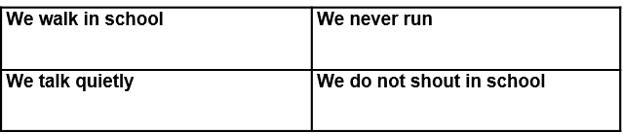  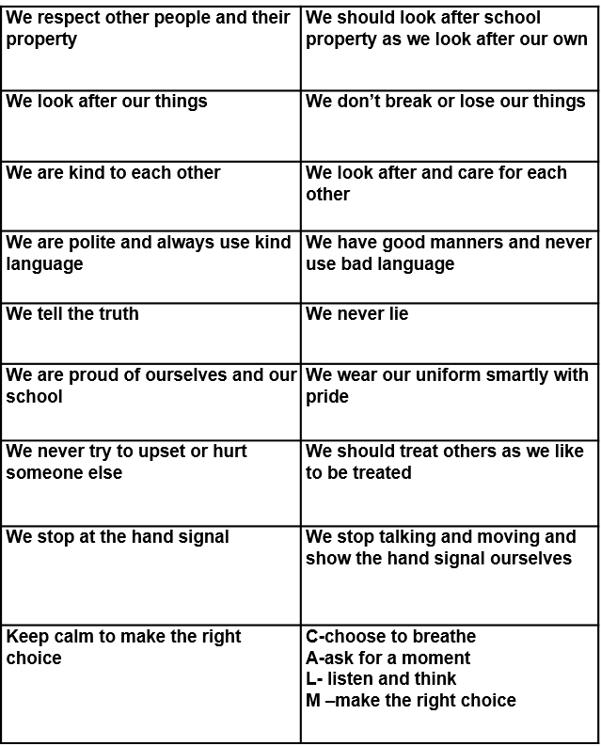  Our rules are based on RESPECT!

